820606400725
ЖУМАНОВА Айнагуль Мухтаровна,
А.Байтұрсынов атындағы №50 мектеп-гимназиясының
ағылшын тілі пәні мұғалімі.
Шымкент қаласы
ANIMAL BEHAVIOUR
Learning objectives(s) |  | 6.C1 Use speaking and listening skills to solve problems creatively and cooperatively in groups (Ex.1,2 p.36)  6.S7 Use appropriate subject-specific vocabulary and syntax to talk about a range of general topics, and some curricular topics (Ex.3 p.36)  6.L2 Understand with little or no support most specific information in extended talk on a wide range of general and curricular topics (Ex.4 p.36)  6.W3 Write with support factual descriptions at text level which describe animals (Ex.5,6 p.36).
Lesson objectives |  | All learners will be able to:  - Identify the theme, new words, understand an interview about animal's behaviour use them as the basis for discussion with a correct grammar tense;  - Transfer the given information into a graphic organizer;  - Offer constructive peer-feedback using rubric.  Most learners will be able to:  - Select, compile, and synthesize information for an oral presentation;  - Demonstrate the ability to write grammatically correct sentences on familiar topics.  Some learners will be able to:  - Respond to and discuss the texts using interpretive, evaluative and creative thinking skills;  - Demonstrate the ability to ask a variety of questions in different tenses.
Plan
Planned timings | Teacher’s activities |  | Pupil’s activities | Marks |  | Resources
Start  5 min | The lesson greeting.  The teacher sets the lesson objectives, letting students know what to anticipate from the lesson.  Asking home task. Ex2,3 p.34 Game “Bingo”  1 2 3 4 5  6 7 8 9 10  Under the questions there is a picture. By this picture pupils must identify the theme of the lesson.  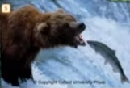  Dived in two groups by animals paws  1st–domestic animals  2nd–wild animals  Introducing with the new words  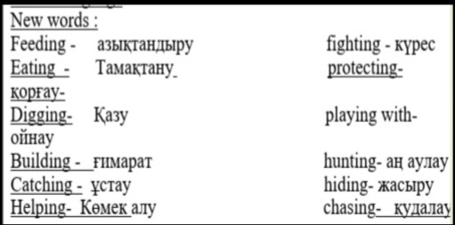  Ex. 1 p.36 |  | Students respond to greeting  Pupils answer by their order in journal  Take the paws. Identify the type of the animals. | 1point  1point |  | PPT  Paws  PPT
Main part  35 min | The main part of the lesson.  Listening (ex 4 p.36)  Try to complete the text. Then listen and check your answers  Pre-learning  Teacher elicits the knowledge of making question rule and helps learners to remember the rules for making affirmative and negative sentences with Present Continuous.  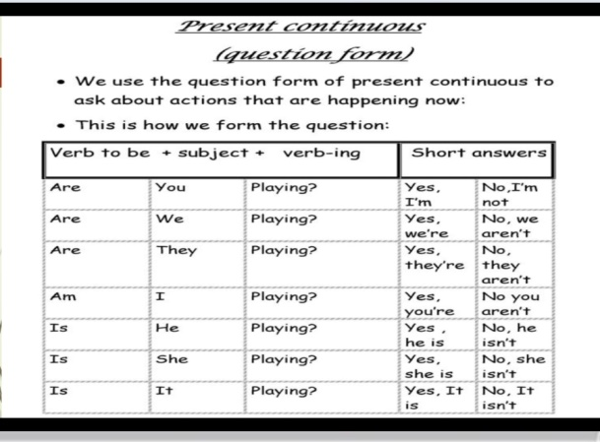  Describing pictures. Game “Snowball”  Each group completes the sentences by the pictures. Then writes the sentences on the sheets of paper, make a snowball and through it to another group. They write the question forms and through it back.  Writing. Ex 2 p. 36  Complete the sentences with the names of animals.  Reflection “Funny hat”  Play the music. Pupils put a “Funny hat” one after one. When the music stops, pupil in a hat answers the question. |  | Listen to the text.  Complete the text  Write sentences  Write questions  Write the names of animals  Answer the question. | 2points  2 points  2 points  2 points |  | www.youtube.com  PPT  snowballs  Textbook  Hat
End  5min | 6.Feedback “Fishbone”    Home task. Write about your favourite animals using the Present Continuous Tense. |  | Pupils write their opinions and fill on the bone |  |  |  | Fishbone

